EXCHANGE THE VALUE OF TWO VARIABLES

INPUT

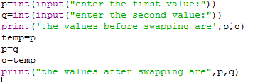

OUTPUT

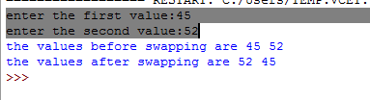

SWAPPED TWO NUMBERS METHOD 2

INPUT

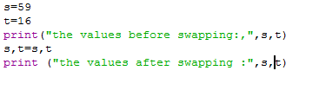

OUTPUT



INPUT

OUTPUT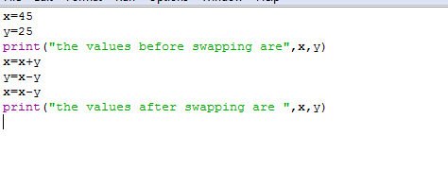

METHOD 4

INPUT

OUTPUT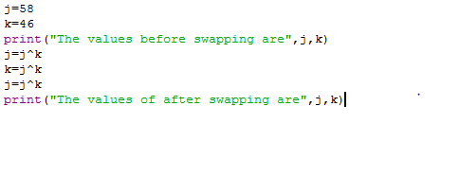

2:CIRCULATE THE n VARIABLES

INPUT

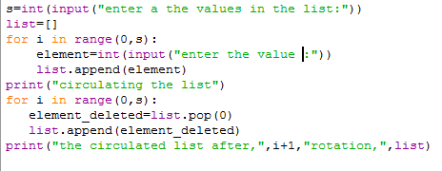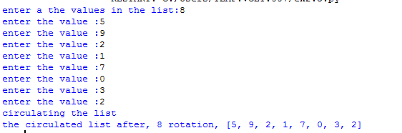

METHOD 2

output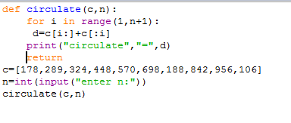

OUTPUT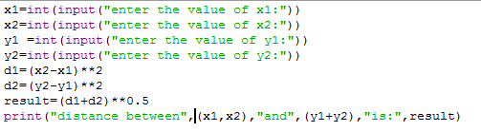 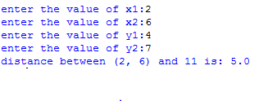

LEAP YEAR OR NOT

input